Add Parts to an Existing Repair Order: This topic covers using ROM to add parts to an existing repair order.

Access an Existing Repair Order: If the screen is blank to start with, either type the RO number in the Repair Order field or use the Search to look it up. If you already have an RO open, you will need to click New Repair Order to clear the screen and open the RO you want to add the charges to.

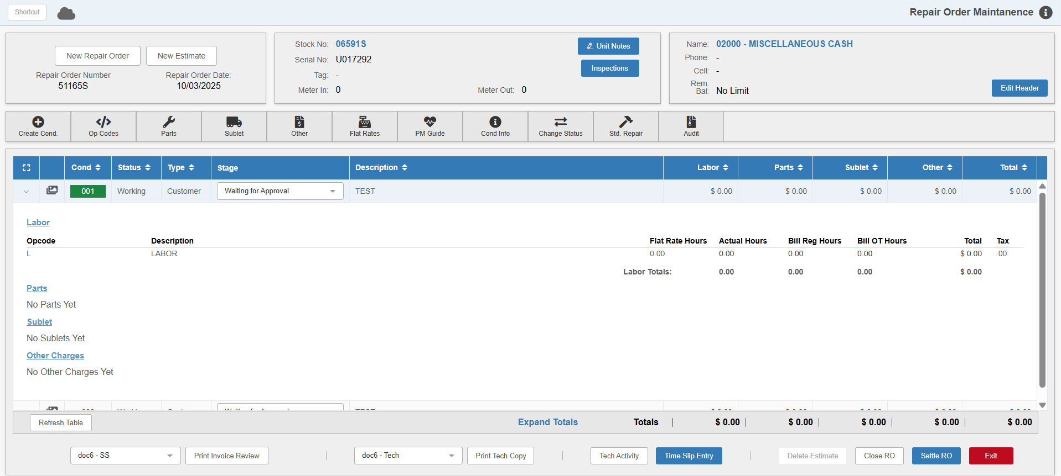

Adding Parts: Expand the condition you want to add parts to, then click the Parts heading. This takes you to the Service Parts POS screen:

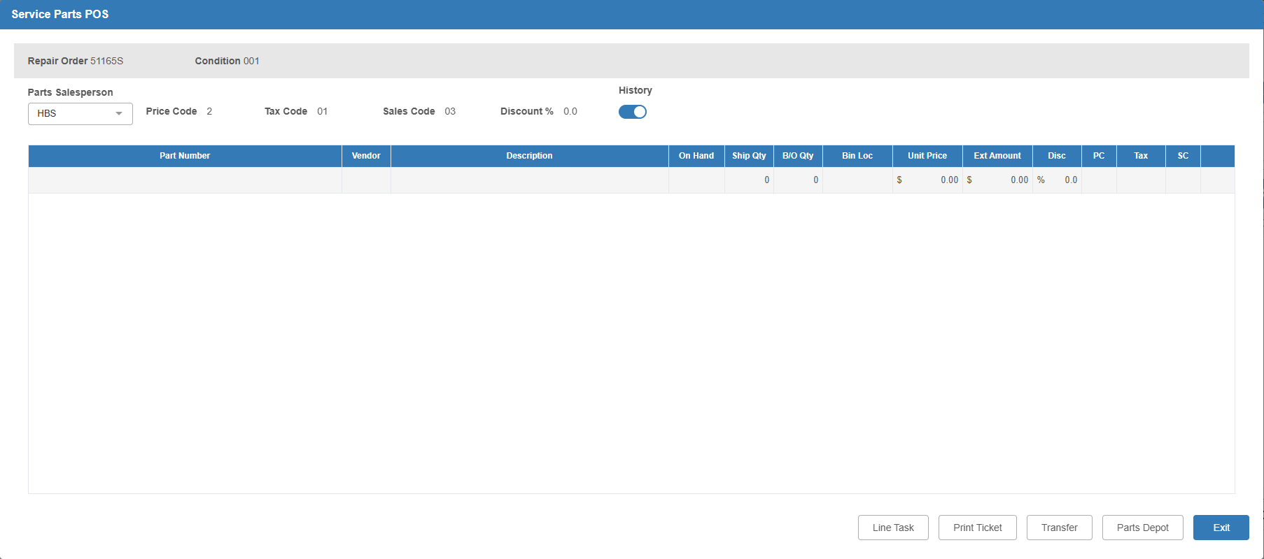

Parts Salesperson: Enter your salesman initials/number.

Parts Sales Grid: Add parts to the RO by entering them into the lines on the grid. Each line will automatically save when added.

- Parts can be placed on back-order just as in POS.
- You can use a variety of line tasks to help you fill in the ticket. Clicking the Line Task button will show you all the available tasks and let you use them, though you can also use them on the part lines themselves as in Point of Sale (POS).
- Parts can be imported through a pick list from a catalog like EPIC, PAL. Solutions, etc. (parts imported no longer have to be in inventory or on-hand).

Exit: Click this button when you’re done adding parts to return to the main ROM screen. The parts are now added to the RO and should show in the condition’s details.

